**Power Pages Exercises**

**Exercise 1: Add a page to your Power Pages site**

1. Go to [Power Pages](https://make.powerpages.microsoft.com/).
2. Select **Edit** on the site you want to add a page. If you don't have a site, [create a site](https://learn.microsoft.com/en-us/power-pages/getting-started/create-manage) before continuing.
3. Select **Pages** and then select the **Add a page** icon (+) to the right of the **Main navigation** heading.
4. Provide a name for your page and select the **Start from blank** page layout.

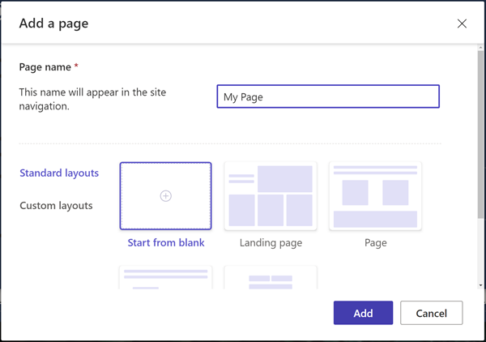

1. After a few moments, you should see blank page with a selection of components to add to the section.

**Design the page and add content**

1. Select the **Text** icon.
2. Enter a name for your page (for example, *My Page*).
   * Change the style to **Heading 1**
   * Select the **B** icon to make the text bold.
   * Adjust the alignment so the text appears centred

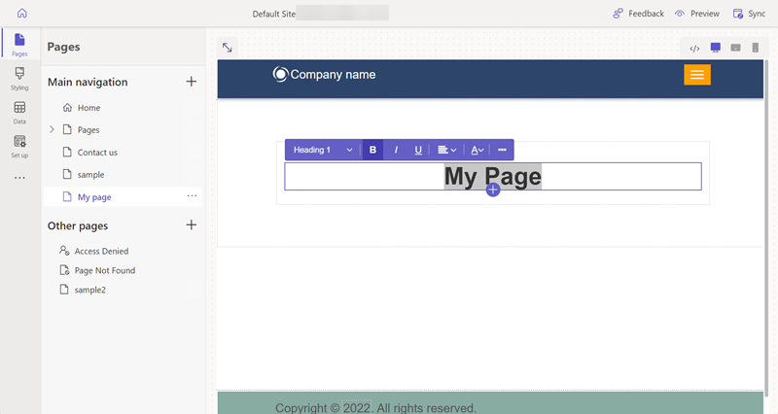

1. Below the text, select the **+** icon and select the **Spacer** icon to add the spacer component.
2. Below the spacer, select the **+** icon and select the **Text** icon to add another text box.
3. Add some text to the text box. Experiment with the style and colors.
4. Select the **+** icon below the text and add another spacer.
5. Select the **Button** component.
6. Configure the following details for the button:
   * **Button label**: *Contact us*
   * Choose **Link to a page**
   * Select **Contact us** page from the dropdown.
   * Select **OK**
   * Use the properties menu to center the button
7. Select the entire section and select **Background** from the properties menu and change the background color of the section.
8. Experiment by adding addition sections, components, and colors to your page.

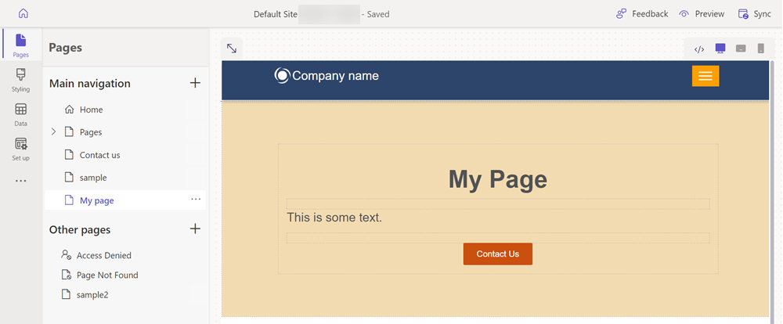

**Preview your page**

You can preview what your page will look like on the site at any time.

1. Select **Preview** from the main menu in the design studio.
2. Choose **Desktop** for the page to appear in your browser, or you can view the page on your mobile device by scanning the QR code.

**Exercise 2: Move the page in the sitemap**

Adding the page to the **Main navigation** will add a menu option. The page can be moved to different spots in the overall site hierarchy using the design studio.

1. Under the **Main navigation**, select the ellipse **(...)** icon and choose Move to other pages.
2. The page should now appear in the **other pages** section. If you now preview the page, notice that there isn't menu item for the page.
3. Under **Other pages**, select your page again and choose to Move to "Main navigation".
4. Select the page and select the ellipse **(...)**, move the page up and down in the hierarchy using the Move up and move down options.
5. Move the page underneath the Pages link. Select the Make this a subpage option to make it a subpage of the Pages page.
6. Preview the page and note how your page is a sub link under pages and how the URL reflects that this page is now a subpage.

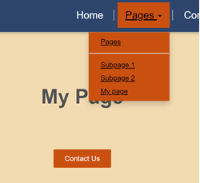

**Exercise 3: Adding your corporate logo to Power Pages**

1. Inside the design studio, mouse over the existing logo and select **Image** when the flyover appears.

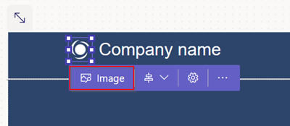

1. Choose an existing image from the media library, or upload a new image.

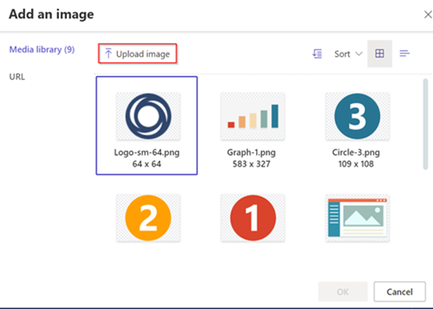

1. Select the image you'd like to use (in this instance, use the corporate logo you uploaded).

**Set your brand color palette**

You can update the color palette to incorporate two or three primary brand colors, and neutral complimentary colors. These colors can be used consistently across your entire Power Pages site.

1. Inside the design studio, go to the styling workspace and select the colors you'd like to use for the background and fonts.

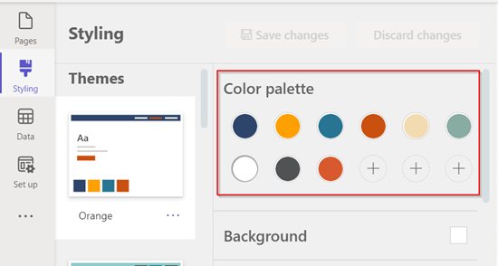

1. Select **Save changes**.

**Set up your corporate brand fonts**

1. Inside the design studio, go to the styling workspace and scroll down to define the font types for headers, sub headers, paragraphs, and buttons.

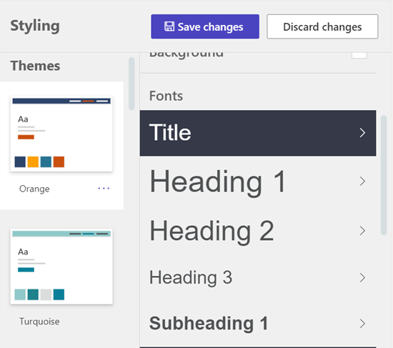

1. You can also adjust the sizes and colors for each based on your color palette. Any updates you make are immediately reflected on your site.
2. Select **Save changes** to update your styling.
   * The theme you updated will have a modified label.

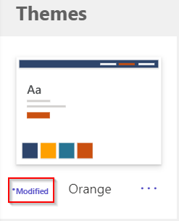

* + If at any time you wish to start over, select the **ellipses** and select **Reset to default**.

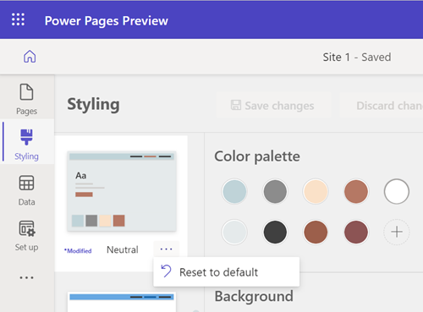

**Exercise 3: Add a list to your page**

## Create a table

1. Select the **Data** icon on the left navigation.

Select the **New table** button.

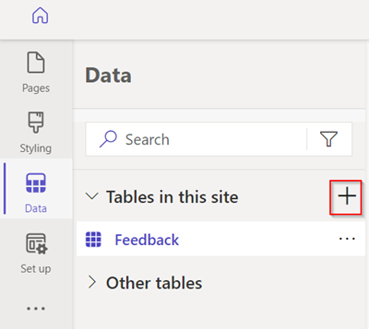

1. Give the table a name and select **Create**.

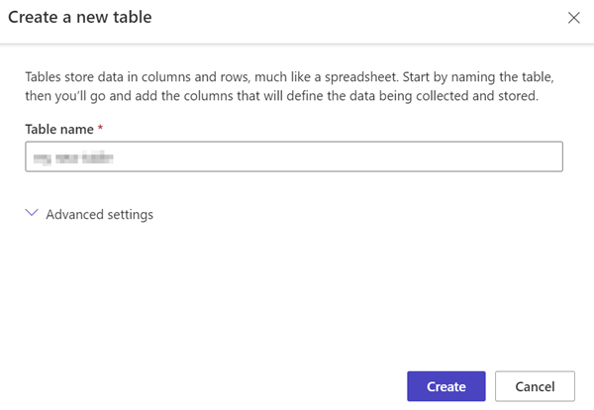

1. Select **New column**.

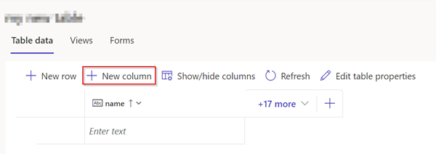

1. Enter a name and a data type, then choose **Save**.

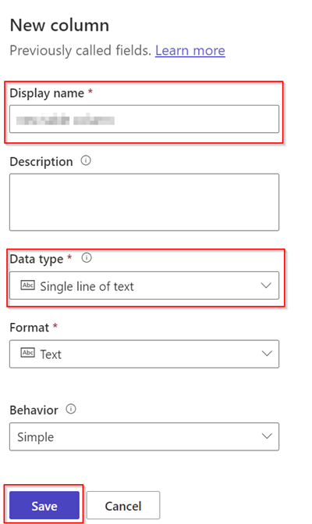

1. Select the space under the name field and enter your data.

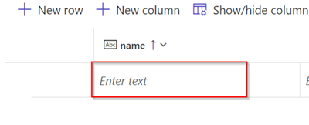

## Create a view

Use the steps below to create a custom view for the table you created.

1. Select the table you created in the steps above.

Select **Views** and choose **new view**.

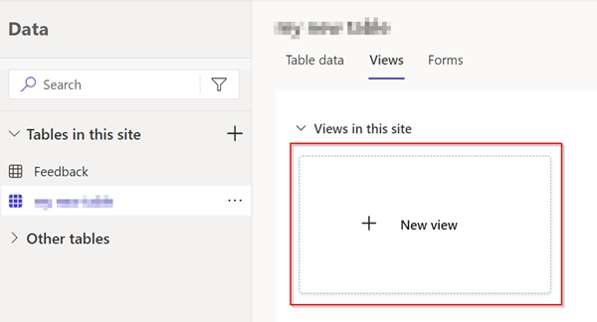

Enter a name for the view.

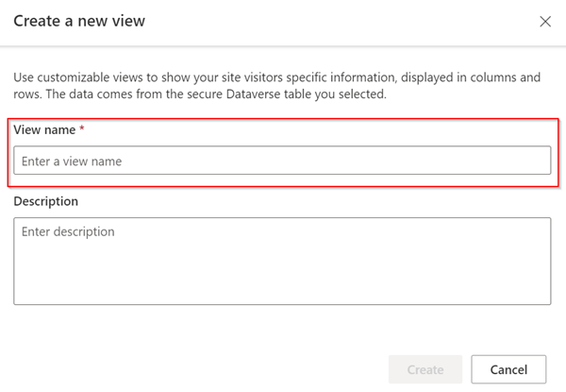

1. Add the application data and status reason columns to the view.
2. Select **Save** and choose **Publish**.
3. Select **Views** to show the available views for the table.

## Add a list to the page

Use the steps below to add a list to a web page so you can view information stored in Dataverse.

1. Inside the design studio, choose the option to **Create a new page**.
2. Add a name for the page.
3. Choose the **Start from blank** layout.
   * Select **Add**.
   * Select **List**.

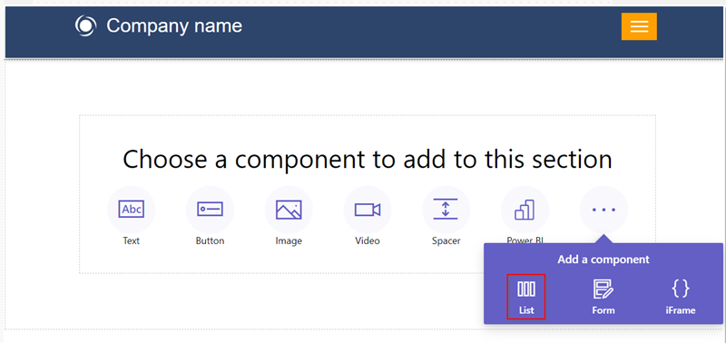

1. Fill in the details.
   * Choose the table and view you'd like from the dropdown menus.

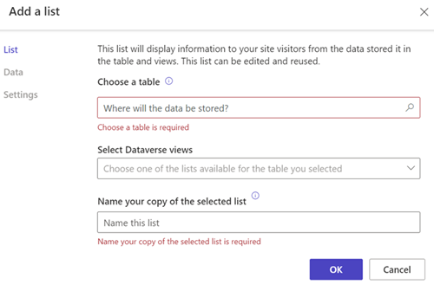

1. Select **Preview**.

The preview icon.

**Note**

When you first view the page, you will see a message displayed that you do not have permissions to view the data. Security is very important when building sites.

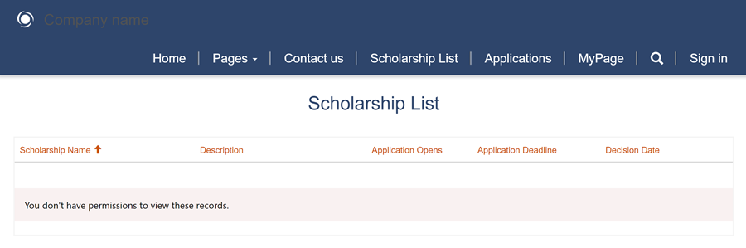

# Exercise 3: Display data securely on your site

## Create table permissions

1. In the pages workspace on the page where you have a list component, select the component and choose the **Permissions** button.
2. Select **New table permissions**.
3. Give table permission a name.
4. Select a Dataverse table.
5. Set the access type to **Global**.
6. Set the permissions to **Read**.
7. Choose **Anonymous** and **Authorized user** for the web roles.

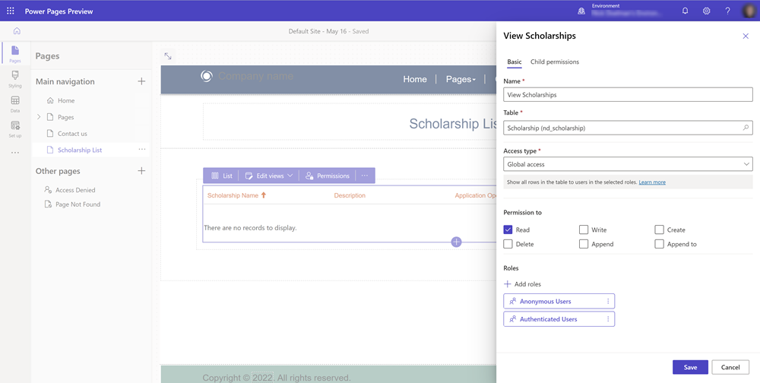

1. Now that table permissions are set, view the page by selecting **Preview**.
2. You should now see a list of Dataverse records on the page.

## Set access type and privileges

1. Create a page with a list showing records that have a relationship to the contact table.
2. From the list on the page, choose on the **Permission** button.
3. Select to create a new table permission.
4. Give the table permission a name and choose **Table**.
5. Select Access type **Global access**.
6. Set permissions to **Read**.
7. Assign the Table permission to the **Authenticated user** web role.
8. Select **Save**.

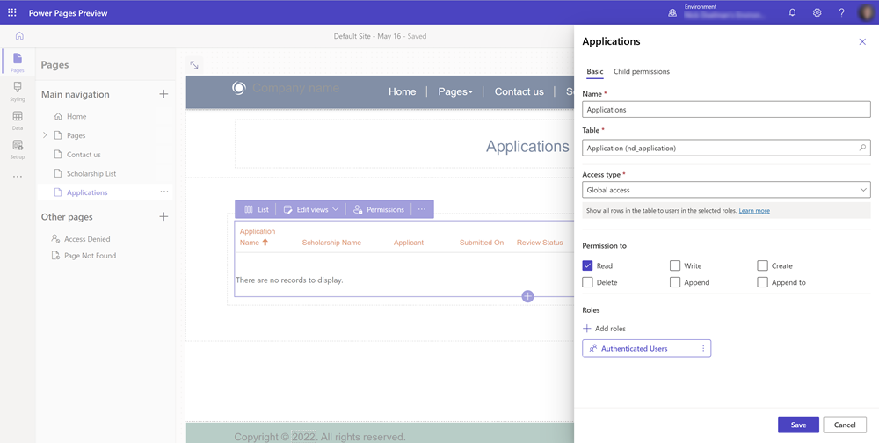

1. Preview the site and sign-in. For purposes of this tutorial, you can sign in using **Azure AD**.
2. View the page on the site. When any user signs in, they should see **all** the data in the table.

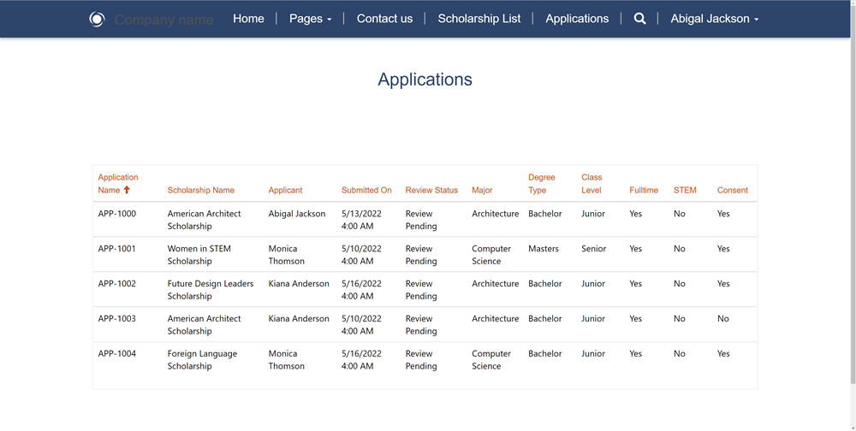

1. In our example, we would only want to show records that related to the currently signed-in user. Return to the design studio, select the list on the page and select permissions.
2. Modify the existing table permission and change the **Access Type** to **Contact Access**.
3. You'll need to specify the relationship between your table and the contact table.

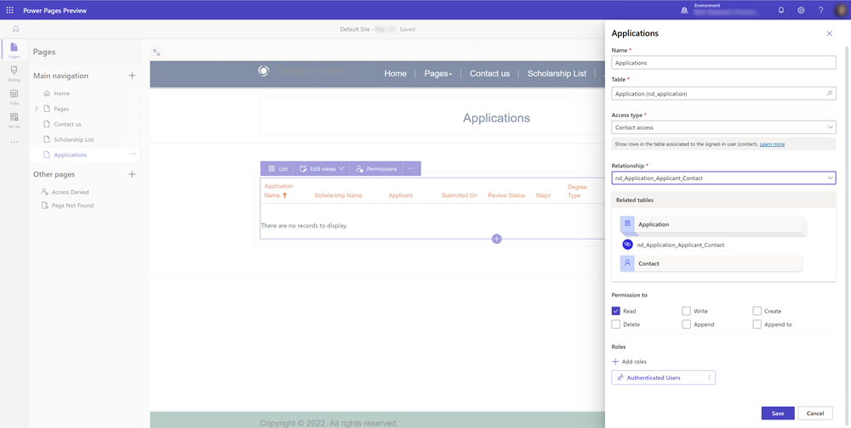

1. Preview the site and sign-in. You now should only see records that are related to the contact that has signed in to the site.

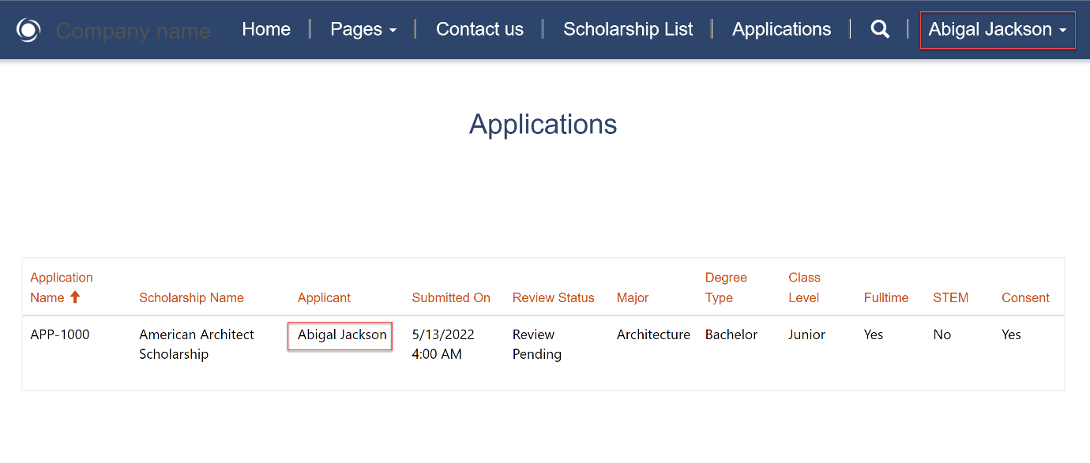

## Add web roles

1. In the design studio, select the ellipses **...** from the side menu and select **Portal Management** to open the Portal Management app.
2. In the Portals Management app, under the **Security** section, select and view **Web Roles**.
3. Select **New** to create a new web role and give it a descriptive name. Leave the **Authenticated Users** and the **Anonymous Users** roles set to **No**.

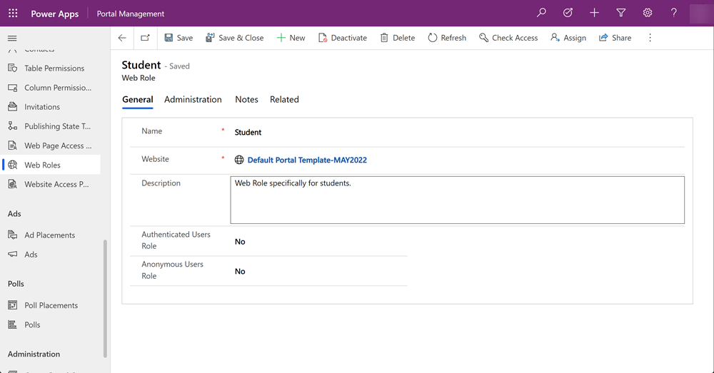

1. Save the web role record.
2. Select **Related** and choose **Contacts**. Select **Add existing contacts** choose a few contacts.

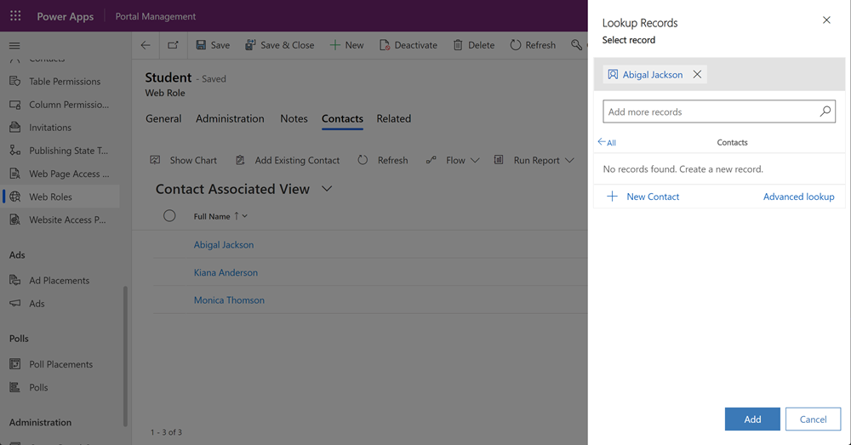

**Note**

Site users are stored as Contacts records.

1. Within the design studio on a list or a form, choose the permissions button and select a table permission, then assign the custom web role.

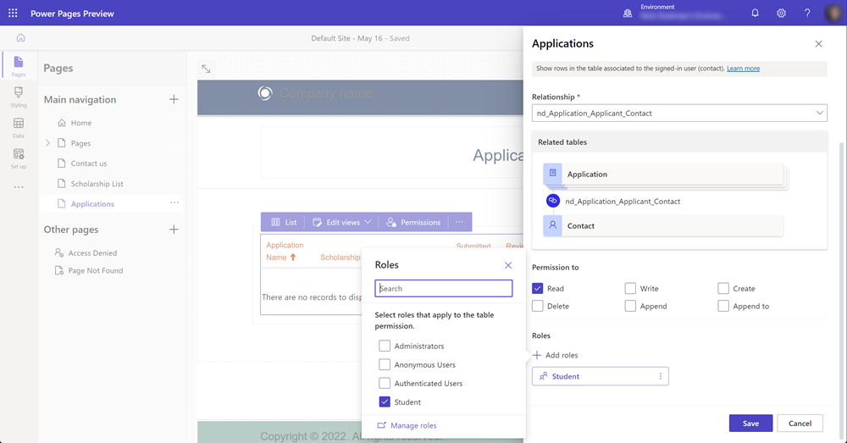

1. Preview the site and note that only users logged in will be able to view the data on a form or list

# Add a form to your page

## Create a form

1. In the **data workspace**, select the **Feedback table** and choose the **Forms tab**.

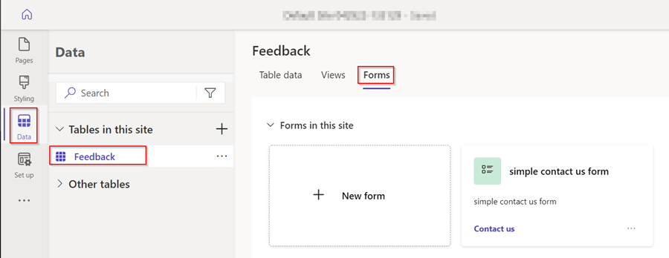

1. Select **+ New form** to open the form editor.

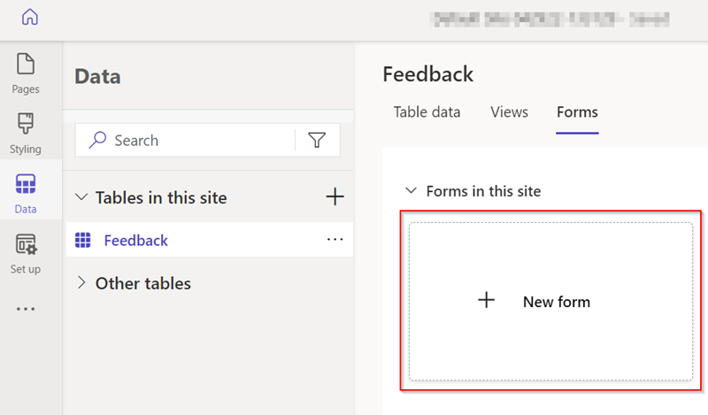

1. Fill in the details.
   * Give the form a name. You can also add a description if you'd like one.
   * Select **Create**.

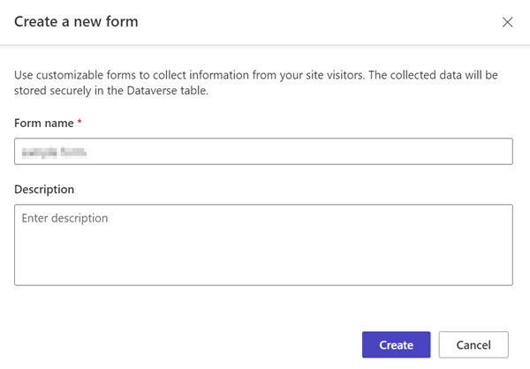

1. Modify the form using the **Add field** menu option, or by dragging and dropping existing fields to reorder them.
2. Select **Publish form**.

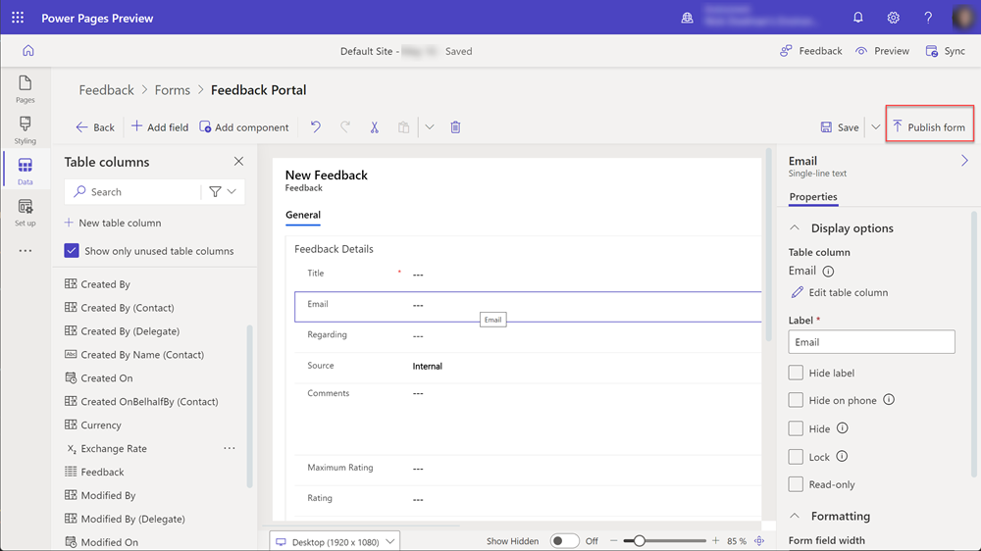

1. Select **Back**.

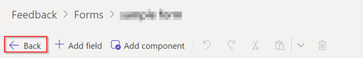

The form will appear in the list of forms for that table.

## Add code components

1. In the **Data workspace**, select the **Feedback table** and choose the **Forms tab**.
2. Select the form you created earlier.
3. Select the **Comments** field on the form.
4. In the right-hand section, choose **Components** and select the **Rich Text Editor** control.

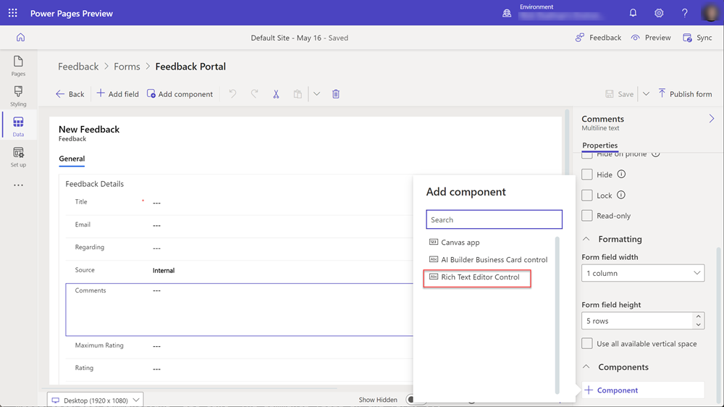

1. Select **Done**.

The form now has a code component linked to the field.

## Add a form to a page

The following steps provide details on how to add your form to a page.

This video provides an overview of the steps to add a form to a page.

1. Open a Power Pages site in the design studio.
2. Choose the **+ icon** next to **Main Navigation** to add a new page.
3. Fill in the details.
   * Give the page a name.
   * Choose the **Start from Blank template**.
   * Select **Add**.

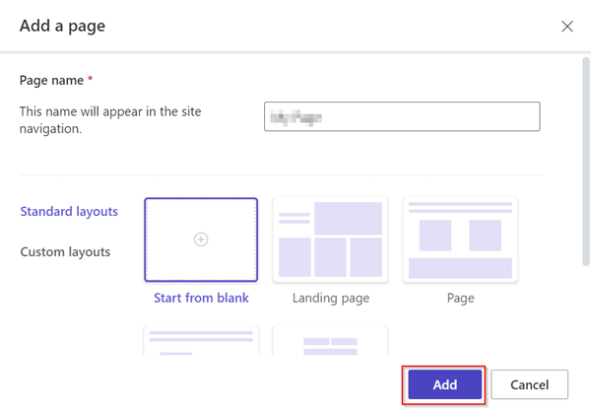

1. Select **Form** from the component bar.

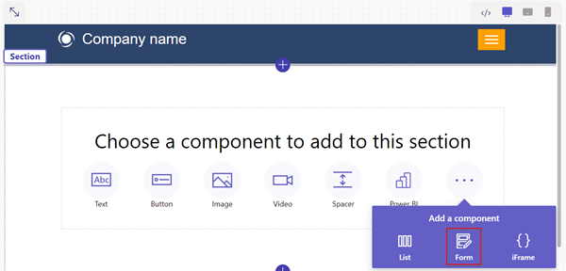

1. Select **+ New form**.

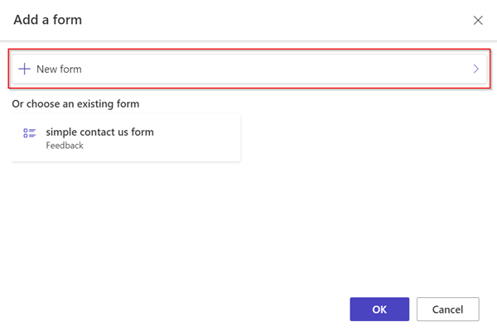

1. Fill in the details.
   * Select the **Feedback table**.
   * Select the form you created previously.
   * Select **Ok**.

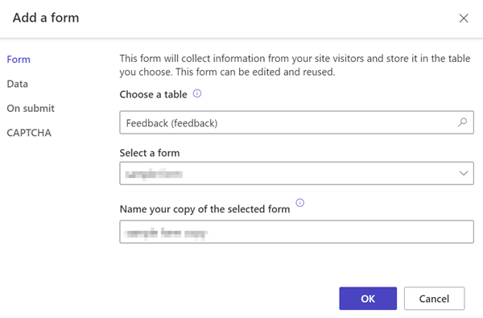

1. Select the **Permissions** button.

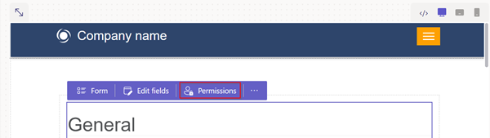

1. Select **Feedback permissions**.
   * Ensure the **Create privilege** is checked and that **Anonymous** and **Authenticated** web roles are linked.

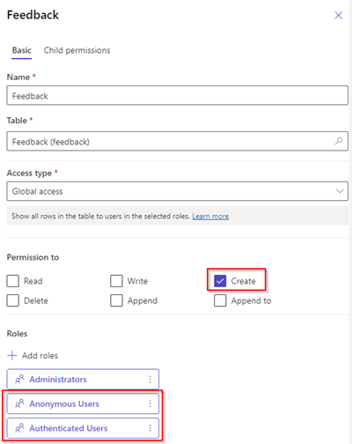

1. Select **Preview page**.

Preview icon.

1. In the design studio, open a page with a form component and select the form you previously created.
2. Select the **Form** button.

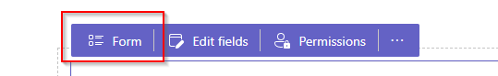

1. Select the **Data section**. Select **Open Portal Management app**. You'll be directed to the form metadata record.

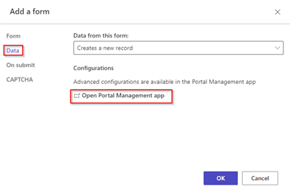

1. Select the **Basic form metadata** tab.
2. Choose **New basic form metadata**.

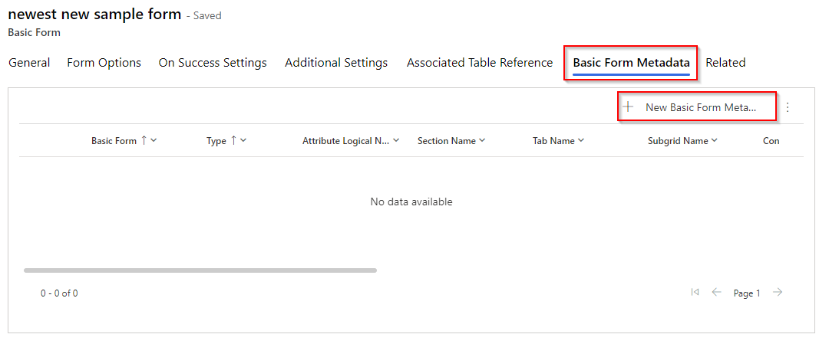

* + Choose **Attribute** for the Type.
  + Choose **Comments** for the Attribute Logical Name.
  + Choose **Code component** for the control style.

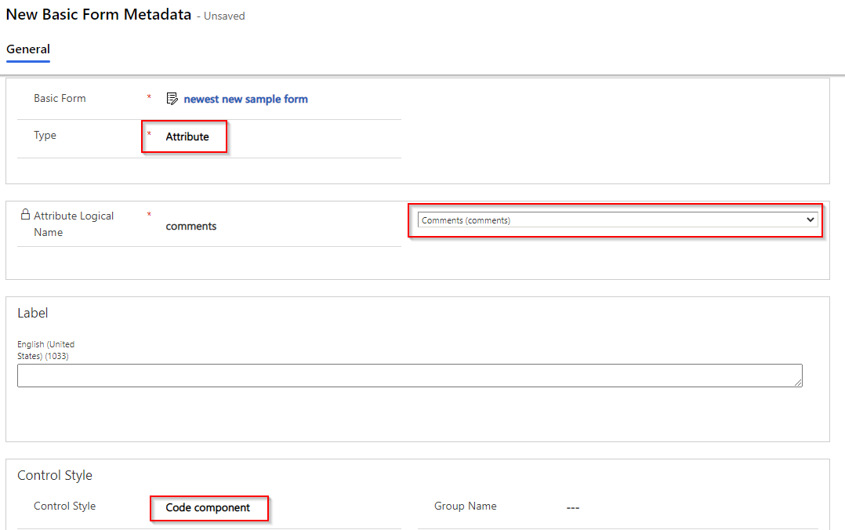

1. Select **Save**.
2. From the design studio, select **Preview** and navigate to your page.
3. The form should show the rich text editor controls on the field.

